REQUIRMENTS MANAGEMENT

This section describes how to define and manage requirements in the Requirements Management (RM) application. You can use rich-text artifacts to define requirements and requirements documents. You can also create and link to supporting artifacts, such as business process diagrams, use-case diagrams, and UI sketches, to elaborate requirements and put them in the broader context of the system and business processes. You can manage requirements by using traceability links, tags, attributes, filtering, and dashboards. With these capabilities, you can create relationships between requirements and other artifacts, categorize requirements, assign properties to requirements, and monitor relationships and status among team applications.

CREATING AND DEFINING REQUIRMENTS IN RM

Create requirements and edit requirement attributes:

1. Login to Requirements Management (RM) [[*https://inbasdpc06348.techmahindra.com:9443/rm/web*](https://inbasdpc06348.techmahindra.com:9443/rm/web)] as an author. Here I am logging in as User ID: *Anup* and password: *Anup*
2. Then select your requirement project and then on the top navigation bar click on **Artifacts** 🡪 Under **Create Artifact** click on **Requirement**.

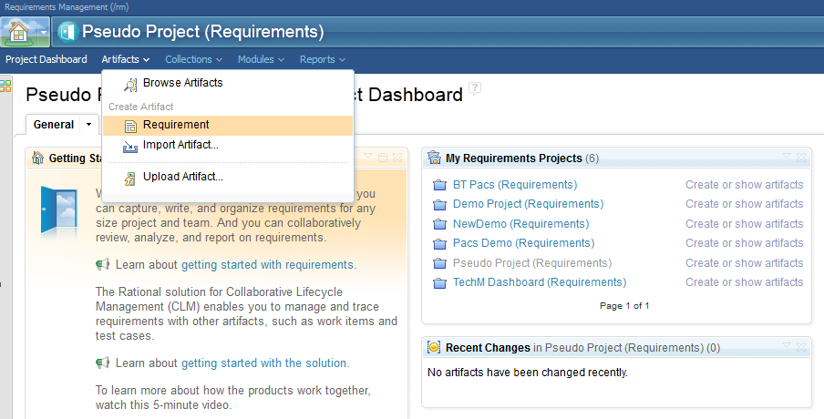

1. Then the **Create New Artifact** window will pop-up. In that enter a name and some initial content for your requirement artifact. If you will check the Open artifact option, the artifact opens in the artifact editor in which you can add content.

.

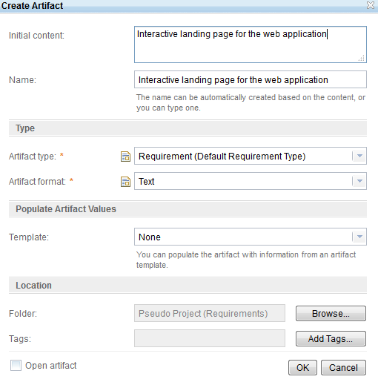

1. Then click on OK to create the artifact. To see your artifact, go to **Artifacts** 🡪 **Browse Artifacts** 🡪 **Click on your** requirements project folder. Then you can see the requirement you created (see the following image).

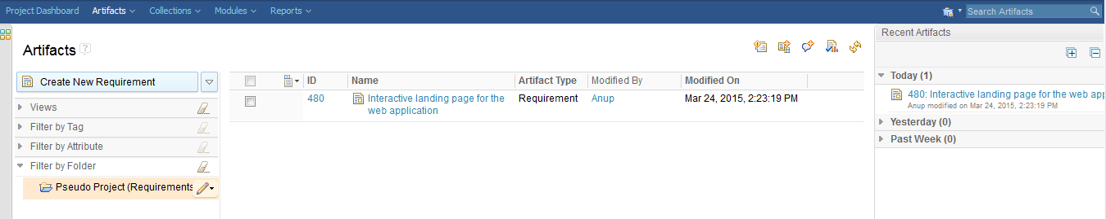

1. Then click on the requirement and your requirement will open. Click on Edit button to edit the attributes.

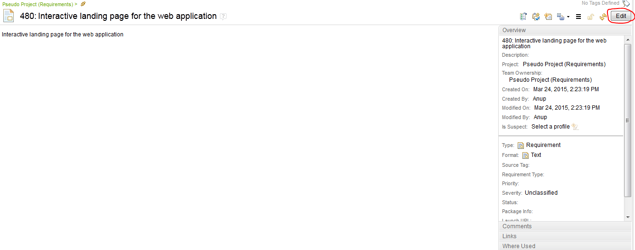

1. Then you can add content and attributes to your requirement, then click on **Done** and click on **Save** to save the requirement.